**Lab – 13: How to register an App in Azure.**

**Objective:** The objective of this lab is –

* To register a new application using the Azure portal.

Any application that wants to use the capabilities of Azure AD must first be registered in an Azure AD tenant.

**Prerequisite:** EMS Enterprise Mobility + Security E5.

**Steps:**

1. Sign in to your Azure Portal, by using the link - **https://portal.azure.com/**. Enter your credentials and click Sign In.

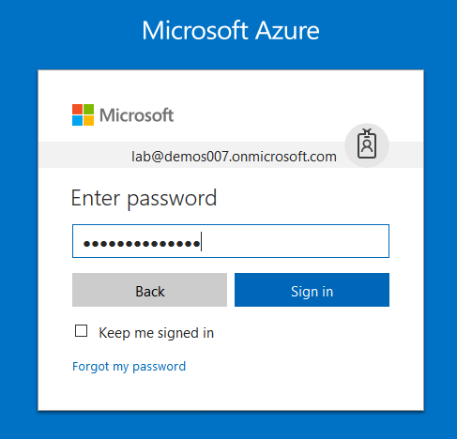

1. Microsoft Azure AD Dashboard will open.

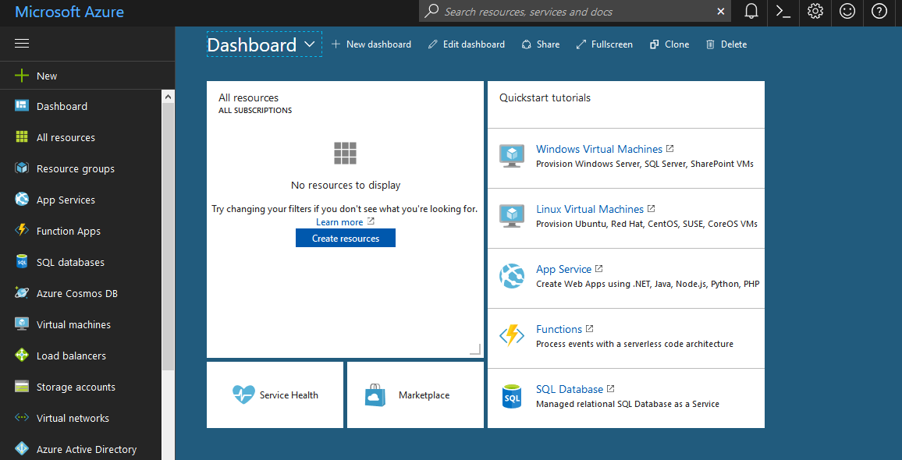

1. In the left-hand navigation pane, click the **Azure Active Directory** service, click **App registrations**.

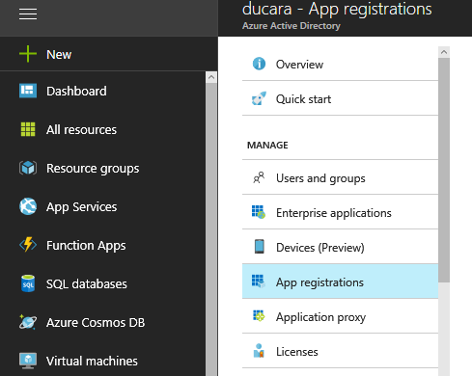

1. Now, click **New application registration** from the top menu.

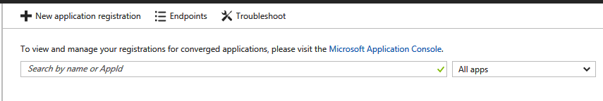

1. Then the **Create** page appears. In this, enter your application's registration information: like – Name, Application type and Sign-on URL.

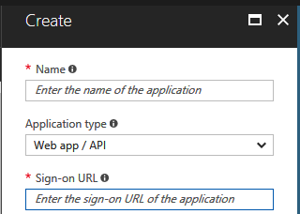

1. Enter a meaningful application name in the Name field.

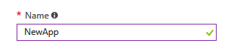

1. In Application type, select **Native**, for client applications that are installed locally on a device. This setting is used for OAuth public native clients. Or select **Web app / API**, for client applications and resource/API applications that are installed on a secure server. This setting is used for OAuth confidential web clients and public user-agent-based clients.

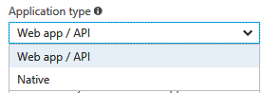

1. For "Web app / API" applications, provide the base URL of your app. For example, **http://localhost:8080** might be the URL for a web app running on your local machine. Users would use this URL to sign in to a web client application.

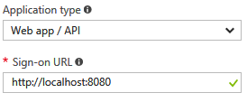

1. For "Native" applications, provide the URI used by Azure AD to return token responses. Enter a value specific to your application, for example http://MyFirstAzureADApp.

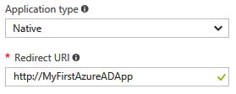

1. Then click **Create**.
2. After successful creation an Azure AD assigns a unique Application ID to your application, and you're taken to your application's main registration page. Depending on whether your application is a web or native application, different options are provided to add additional capabilities to your application.

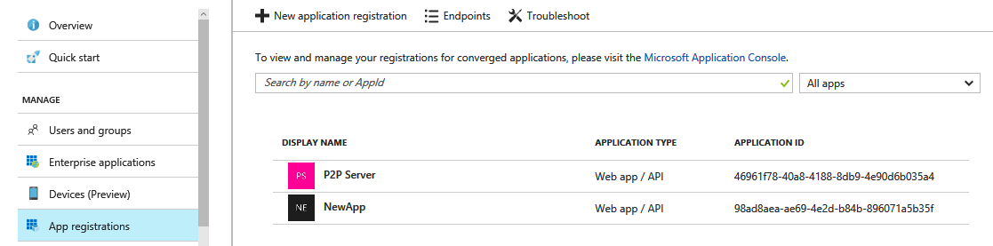

1. So, this is how you can register or add an app using Azure AD.